DELPHI WEB STUDIO PRO

Test Guide
A practical acceptance session using a disposable website
Use a small practice site to check the Windows build before trusting a change with important work. Each exercise explains the expected result and what to record if it differs, so testing produces a useful answer rather than a collection of unexplained screenshots.
Windows desktop edition
Last changed November 10, 2026
Illustrated explanations and examples for the Win32 and Win64 desktop editions.

Contents
Prepare a practice session 3
Create pages and verify the command targets 3
Exercise objects text panels and layered selection 4
Import organize and reuse media 4
Test visitor behavior and responsive output 5
Confirm save overwrite reopen and close 5
Review the export and leave a useful result 6

Prepare a practice session
Begin with a disposable project and a separate location for test output. Riverside Community is a useful name because it is easy to distinguish from a real site. Keep one small image and samples/Community_Bulletin_Sample.pdf available, and note whether you are running Win32 or Win64. When both builds are distributed, repeat the relevant desktop checks independently in each.
Run DelphiWebStudioPro.exe from the intended bin folder with its adjacent editor directory and matching loader. Confirm that the window opens and the Dashboard is usable. If startup fails, record the status and Diagnostics result before changing anything. Check for the local bundle and WebView2 Runtime rather than clearing application storage.
The following exercises remain local. They do not require publishing, live credentials or sending a contact message. Use a fresh test profile when automated testing would otherwise add drafts or media to your normal work.

Create pages and verify the command targets
Choose the Community starter, change the Home headline and create News at /news. Select News, then Home, and watch the fixed icons beside Add page. Their positions should stay constant while their target follows the selected page. Use Go to page to confirm that the same selection works even when many tabs would overflow the strip.
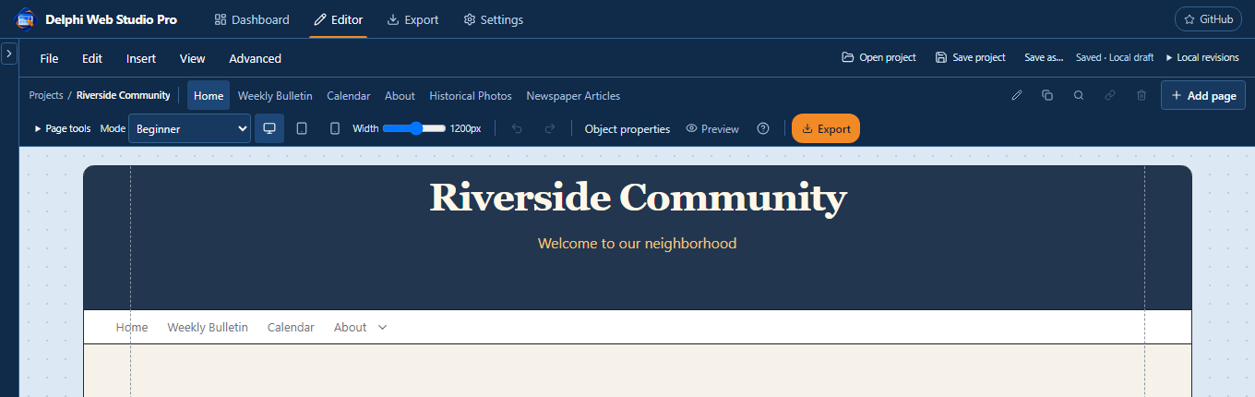
Page selection and the fixed action group should refer to the same page.
Rename News in the editor without changing /news, then use a disposable edit to try Undo and Redo. Change a non-Home address with supported link updates and confirm that the result remains unique. Cancel a deletion once before confirming any disposable removal, so both paths receive attention.
Record the page name and action if the wrong page changes. That is more useful than simply reporting that the toolbar failed, because a stale dialog or selection identity can produce a very specific targeting problem.

Exercise objects text panels and layered selection
Add a Content block with two sections. Drag the divider to make one side wider, then place a photo in the first section and a panel with text in the second. Select and resize each independently. Move the panel and verify that attached text travels with it, while an unrelated overlapping object stays independent.
Double-click the text, select a few words and change their color and size. Apply paragraph alignment to the intended range, then create a link on selected words with Link or Ctrl+K. Move the whole text object to another section and move it again, checking that emphasis, font and links remain intact after both operations.
Use Layers and Alt-click to reach covered items, and check that handles follow the current geometry rather than the original size. With compatible objects in one section, try alignment and distribution. If a drag fails, record the start item, destination section, pointer sequence and visible result; automated tests should use real pointer-down and pointer-up events for this path.

Import organize and reuse media
Open Manage Media and create Events and Bulletins. Import the sample image and PDF, place them in their folders and confirm that each filter shows the correct item. Choose the image through the Media library and place it on the page, then move that asset to another folder through Manage Media.
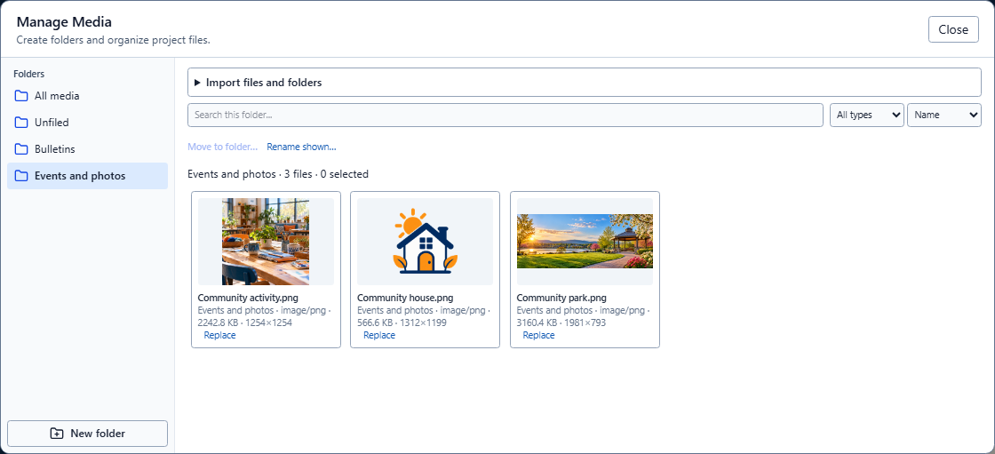
Folder movement should organize the library while preserving the picture and PDF references already used by pages.
The image on the page should still display. Save and reopen the project later to confirm that folder membership also survives packaging. Try choosing an asset from an existing image property and check that it updates the property rather than creating another page object. Use a duplicate file to exercise the import matching policy without unnecessarily multiplying a large test collection.

Test visitor behavior and responsive output
Add About at /about and a Navbar with Home and About. Put News under About as a submenu item. In Preview, click About itself, open its separate arrow and choose News. Press Escape with the submenu open and confirm that focus returns to the arrow. Repeat navigation from a scrolled source page, checking that an ordinary destination starts at the top and an anchor opens its named location.
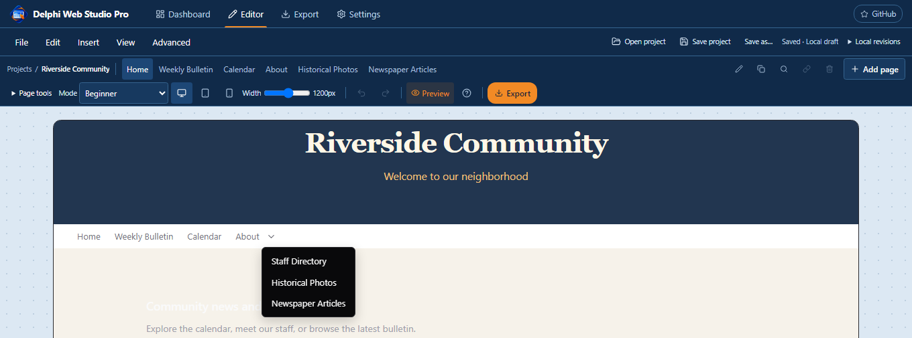
A parent link and its dropdown need separate click and keyboard checks.
Add the sample PDF to a viewer or bulletin list and try page navigation, zoom and scrolling. Create a Calendar event and a Team Directory biography longer than two lines, then check their visitor controls. A long biography should open in a scrollable reader rather than stretching the whole directory row.
Inspect Desktop, Tablet, Mobile and an intermediate width. Look for image distortion, large empty gaps, covered text, unintended dark backgrounds and horizontal overflow. Compare the same content in the exported website rather than assuming that a correct React preview proves the static renderer.

Confirm save overwrite reopen and close
Save the practice project to a new .webstudio.zip and record the destination. Change a line, use Save to update that same file, and reopen it to verify the actual stored text, image, PDF and folders. Open the same saved version again and check that it does not add another identical draft. Keep a separate changed snapshot when testing different-version behavior.
After a confirmed save with no later edit, try the window X and File > Exit in separate runs. A clean project should close without another save prompt. Make a new edit and try Cancel, then Yes with a cancelled save, and finally a successful save. The editor should remain open whenever a requested save fails or is cancelled.
Use Save as for an independent filename and check that later Save follows the new destination in that desktop session. When testing a failure, use synthetic files and a controlled unwritable or changed target. Do not corrupt a real project or infer power-loss safety from a single successful replacement.

Review the export and leave a useful result
Export the practice site and inspect index.html, the generated page files and referenced assets. Open the reviewed site over local HTTP where available, then follow the Navbar, inline text link and anchor again. Check the PDF under HTTP because direct file access can prevent its modules from loading normally.
For each failure, record the application revision or stage, architecture, project fixture, page, control, expected behavior and actual behavior. Include a screenshot for visual problems and the relevant status for file operations. A concise reproducible sequence is more helpful than a large directory of nearly identical test captures.
When the session is finished, close only the test-owned app or browser instance, stop the local review and remove the disposable profiles, extracted websites and generated test copies you created. Preserve deliberate evidence and any requested result. Passing this session establishes the exercised paths; it does not replace clean-machine, accessibility or real-host acceptance.

